A310 FINAL REVIEW
Problem #1

Name the famous dead dude/thing that is known for the following:
- Developed 3 laws of motion and universal law of gravitation?

- Held that the Earth belonged to a heliocentric solar system?

- Enhanced the geocentric universe model by adding circles for the orbits of heavenly bodies?

- Was known for precision astronomical observations of Mars and a really bad nose job?

- Showed that the passage of time is dependent on speed, and that if you are really smart you don’t need to comb your hair?

- Developed the first Geocentric Universe model?

- Developed the 3 laws of planetary motion?

- Made the first telescope and experimentally showed different size masses fall at same rate?

- Who made the first liquid fueled rocket?

- Creator of the V-2, first ballistic missile?

- The name of the first man-made satellite?

- What did the first U.S. Satellite, Explorer I, find?

- Who developed the first communication satellite, and what was its name?

- Who was the first man on moon?

Problem #2

List and describe the Following:

Kepler’s Laws:
1)

2)

3)

Newton’s Laws:
1)

2)

3)

The Universal Law of Gravitation)

Problem #3

We would like to design a re-entry vehicle, what are the three methods of dissipating the heat generated during re-entry?

If we have two objects of equal mass and frontal area are entering the atmosphere with the same velocity and entry angle. We only have two designs to work from, one is very streamlined and the other is very blunt-ended. Identify which design will give us the desired characteristics below:

(Streamlined / Blunt-ended) has low ballistic coefficient.
(Streamlined / Blunt-ended) will experience a high maximum heating rate.
(Streamlined / Blunt-ended) will experience more deceleration early in the entry.
(Streamlined / Blunt-ended) can achieve better accuracy because it spends _______ time in the atmosphere.

Problem #4

We would like to launch a satellite on a Delta IV rocket from the Kennedy Space Center (28.5 deg N, 80 deg W). The satellite will be placed into a 24 hour circular, 55 degree inclined orbit with a RAAN of 150 degrees. The current LST at the launch site is 0600.

How many launch opportunities do you have, and what latitude must we move the launch site to only have one launch opportunity? Solve for the LWST at the ascending node opportunity to determine the time until the satellite can be launched and find the launch azimuth.

We would also like to understand the velocities needed to get to orbit. Which coordinate system should we use? if we know that we will have 1.5 km/sec of losses, what is the ΔV_{design} needed?

# of Opportunities = _______

New Launch site latitude = _______

Time until launch = _________

Coordinate system = _________

ΔV_{design} = _________
Problem #5

Given the following 6 Hazards of Space, describe the effects on spacecraft/astronauts.

- Charged Particles

- Atmosphere

- Micrometeoroids and Debris

- Vacuum

- Radiation

- Gravity

Problem #6

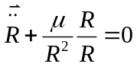List 4 of the assumptions we make to come up with the restricted 2-body equations of motion. Write the equation that is the solution, given the assumptions above, to:

Problem #7

Fill In the following chart:
Conic section a e ε
Circle
Ellipse
Parabola
Hyperbola

Problem #8

NASA wants to place a communications satellite in a geosynchronous circular orbit with an altitude of 35782 km and inclination of 0°. The satellite is currently in a circular orbit with an altitude of 300 km and inclination of 28.5°. What is the total ΔV needed, where should we perform the combined plane change, and how long will it take?

ΔV₁ = ____________

ΔV₂ = ____________

ΔV_{TOTAL} =_________

TOF = ____________

Problem #9

Given the following diagram of an elliptical orbit, define the 6 COEs, tell whether they are constant or variable, and what they describe about the orbit, as well as the following vectors: k, I, n, & e. List whether the COE is effected by J2 or Drag perturbations.

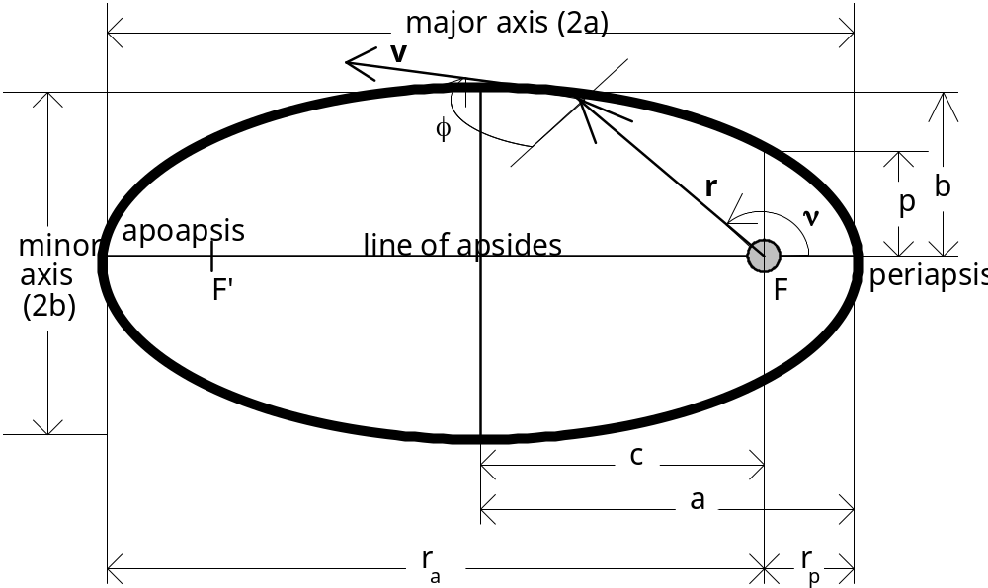

a)

e)

i)

Ω)

ω)

υ)

k)

I)

n)

e)

Problem #10

List the 5 Advantages of space and describe a mission that would be associated with each advantage.

1.
Mission:

2.
Mission:

3.
Mission:

4.
Mission:

5.
Mission:

Problem #11

NASA controllers want to maneuver the shuttle to rendezvous with a satellite. How long do they need to wait before they begin their maneuver? Draw a picture showing the relative starting positions. Label the interceptor and target.

Space Shuttle Comm. Satellite_______________
R = 6578 km R = 6878 km
e = 0 e = 0
u = 90° u = 220°

W.T. = __________________________
Problem #12

NASA controllers decided to visit another satellite in the same initial orbit first. The target satellite is 30° ahead of the Shuttle in the proper orbit (R=6578 km, i=28.5°, e = 0). Assume the Space Shuttle is the interceptor and the satellite your target. What is the semi-major axis of the phasing orbit to complete the rendezvous, how long will this maneuver take to complete, and what is our radius of perigee?

Problem #13

You are sending an interplanetary probe from Earth to Ceres. Assume parking orbits and asteroid orbits around sun are circular. Given the following:

- R_{TO_CERES}=3.89X10⁸ km
- R_{TO_EARTH}=1.496X10⁸ km
- μ_{SUN}=1.327X10¹¹ km³/sec²
- μ_{CERES}=200 km³/sec²
- μ_{EARTH}=398600.5 km³/sec²
- R_{PARK@CERES}=900 km
- R_{PARK@EARTH}=6978

How long will this trip take?

Calculate V_{∞ Earth}. Draw a picture showing where the probe reaches this velocity (HINT: Earth centered picture).

What is the ΔV_{Boost} required to depart Earth on our trip?

Problem #14

Given the R & V vectors for each problem below, determine the COEs (hint: your whiz wheel will be helpful for some, but not all, COE calculations).
1 | 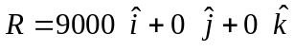  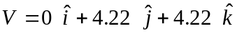 | a | = | ___________ | Ω | = | ___________
1 |  | e | = | ___________ | ω | = | ___________
1 |  | i | = | ___________ | ν | = | ___________
2 | 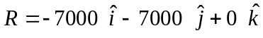  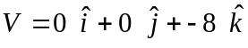 | a | = | ___________ | Ω | = | ___________
2 |  | e | = | ___________ | ω | = | ___________
2 |  | i | = | ___________ | ν | = | ___________

Problem #15

Given the following, where will the satellite be in 45 minutes, i.e. find final True Anomaly (ν_{f})?

Semi-major axis (a) = 22560.274 km Right Ascension of the Ascending Node (Ω) = 270º
Eccentricity (e) = 0.35 Argument of Perigee (ω) = 90º
Inclination (i) = 63.4º True Anomaly (ν_{i}) = 180º

Problem #16

Answer the following with regards to ground tracks:
- From a ground track, how do you identify the inclination of an orbit?

- If ΔN is 65° from a ground track, what is the period of the orbit?

- The ground tracks of a geostationary or geosynch orbit looks like what?

- Which COE do we not generally find from the ground track (unless we have a time reference), and which COE can we calculate from a ground track?

Problem #17

Given the following:
Subject: Track Glacial Melting: at 32.0 degree Fahrenheit
Mission Altitude: 250 km
Payload Sensor Data: Aperture = 2 m, Detector radius = 0.05 m, focal length = 0.20 m

What is the wavelength we need to use to observe the subject? (Hint: Use Wien’s Law.) What is the swath width and resolution at this altitude? What is the current field of view?

What can we do to get better resolution or a larger swath width?

If we can point to within an accuracy to 0.001 radians. What is our pointing stability (approximate diameter of the target)?

Problem #18

Use the following satellite specifications to determine if the EPS and Communications subsystems are sufficiently sized (Problems 18 & 19):
- The transmitter/receiver on a GEO communication bird needs 11250 W of Power.
- The bus requires 350 W of power
- The orbital altitude is 35782 km.
- The mission duration is 15 years.
  - Proposed Electrical Power Subsystem (EPS):
    - Body-Mounted Solar Arrays which has 28% efficiency
    - Effective solar panel area is 5m X 2.5m.
    - Assume a compounding degradation of 2.2% per year.
    - The Nickel-Cadmium battery has max capacity of 12000 W-hr.
    - For Depth of Discharge (DOD) use this table:
Orbit | Period | DOD
LEO | 90 min – 6 hr | 25%
MEO | 6 hr – 12 hr | 50%
GEO/HEO | > 12 hr | 75%

What is the Solar Array Margin and Battery Capacity Margin?

Problem #19

  - Proposed Communications and Data Handling System (CDHS):
    - Transmitter Gain: 150
    - λ: 12.55cm
    - Receiver Gain: 500
    - Receiver Temperature: 295.37 ˚K
    - Bandwidth: 12.5 MHz
    - Total RAM: 120MB

What is the Signal to Noise Ratio, and how many communication packages can be stored on board before we need to downlink if a communication package requires 1.5 kB of data?

Problem #20

A 750kg satellite has one of its sides (1.3 m2) in direct sunlight. Another side (also 1.3 m2) is exposed to the Earth. Each side has an absorbtivity (α) of .3. The satellite has two radiators with an emissivity (ε) of .7, two of the remaining sides have an emissivity (ε) of .3 on each side (same area), and the remaining two sides only have an emissivity (ε) of .15 on each side (same area). Systems on-board are generating 650 Watts of heat.
- What is the equilibrium temperature of the satellite while in the sun?

- If we need to lower the equilibrium temperature of the satellite by 20°C (to allow for more efficient payload operations); What value of emissivity should be selected for these sides, if we are allowed to add radiators with louvers in place of the two sides with an emissivity (ε) of .1? The louvers may vary their emissivity between the following ranges (.8-.2).

- What is the spring constant of the satellite if fundamental frequency is 44Hz, and what can we do to the satellite to bring the fundamental frequency above the launch vehicle’s 55Hz fundamental frequency?

